Classification of Electroencephalogram Generated by Brain
for Analysis of Brain Wave Signals in Students Depression

Aditya Dimas
Faculty of Science and Technology,
Universitas Teknologi Yogyakarta adityadimas@staff.uty.ac.id

ABSTRACT
Electroencephalogram (EEG) is a brain signal processing technique used to detect abnormal brain waves. EEG signal recording uses electrodes placed on the scalp. AD620 is used to obtain high input impedance. The EEG signal is amplified by transmitting the signal into the notch filter, high pass filter and low pass filter to improve the quality of the signal such as eliminating and reducing noise. EEG recording focuses on analyzing alpha waves to determine whether the subject is students who suffering depression. For cases of depression, the lobes of the brain placed electrodes are the Occipital and Parietal lobes of the brain. The selection of participants in this study was based on the results of tests using the Student Health Questionnaire-9 (PHQ-9) method. The results obtained after recording EEG showed there was theta wave shaped abnormally large and abnormal alpha wave who shaped abnormally large.

Keywords: EEG, emotion, Discrete Wavelet Transform, Artificial Neural Network, backpropagation

INTRODUCTION
The human brain is one of the most complex systems in the universe and consists of billions of brain cells called neurons, which are the coordinating center in the human body to communicate with each other. Currently various technologies exist to record brain waves and electroencephalogram (EEG) is one of them (Sasikumar Gurumurthy, 2013).
EEG is an instrument used to record static electrical activity resulting from stimuli received by the brain (M.E. Chandrasiri, 2013). The EEG signal consists of frequency components that are represented in the time domain. The frequency component of the EEG signal informs the condition of the brain and direct visual observation of the EEG signal is very difficult considering the very low amplitude of the EEG signal and the very complex pattern (Wahyu Eko Zulianto, 2016). In addition, the EEG signal is strongly influenced by various variables, including mental conditions, health, activities of the patient, recording environment, electrical disturbances from other organs, external stimuli, and the age of the patient (Esmeralda C. Djamal, 2005). One form of measurement on the EEG signal is a measurement made to see the wave pattern of a person's level of depression.
Depression is a mental disorder that develops worldwide that has a direct effect on brain performance [Yousef Mohammadi, 2019] and according to the World Health Organization (WHO), by 2020, depression will be the second most significant disorder after cardiovascular disease with more than 350 million people. (Mojtaba Hajian, 2017).
Diagnosing the degree of depression in its early stages is very important because depression affects everyone regardless of age, geographic location, demographics or social position and affects women more often than men (U. Rajendra Acharya, 2015).
This system focuses on alpha wave analysis to determine whether the subject is suffering from depression. For cases of depression, the lobes in the brain that will be paired with electrodes are the Occipital and Parietal lobes of the brain with the classification that the subject is declared depressed if the basic frequency is below 8 Hz and is said to be normal if it has a basic frequency of 8 Hz or more (Shamla Mantri, 2015).
The international standard 10-20 electrode placement system was used to collect EEG data.
The EEG signal is measured by placing number of electrodes on the scalp. Before electrodes are placed first coated with conduction paste which aims to reduce signal attenuation (Jian Shen, 2017).

II. BASIC THEORIES
Electroencephalogram
An EEG is an instrument used to capture electrical activity in the brain. EEG reflects the working status of the human brain and is considered the best physiological data that can be used as a tool to detect and diagnose depression of a disorder [Jian Shen, 2019].
Visual observation of the EEG signal directly is very difficult considering the amplitude of the EEG signal is so low (100 V – 1 mV) and the pattern is very complex. In addition, the EEG signal is strongly influenced by various variables, including mental conditions, health, activities of the student, recording environment, electrical disturbances from other organs, external stimuli, and the age of the student (Esmeralda C. Djamal, 2005).
Based on the analysis of brain waves that have been obtained through EEG, we can classify the characteristics of these brain waves into normal brain waves and abnormal brain waves. The results of the EEG examination showed differences in brain wave patterns as follows (Jan Nissl, 2006):
- Normal
- The results of the two sides of the brain show a pattern similar to electrical activity.
- Awake adults, EEG show more alpha waves compared to beta waves.
- No abnormal wave picture of electrical activity and no slow wave.
- If the patient is stimulated by light (photic) during the test then the wave results stay normal.
- Abnormal
- The results of the two sides of the brain show no pattern similar to electrical activity.
- The EEG shows the image of the waves sooner or later, this thing may be caused by a brain tumor infection/inflammation, injury, stroke or epilepsy.
- Various circumstances can affect EEG image. An abnormal EEG can be caused by abnormalities in the brain not only limited to one specific area in the brain, e.g., drug intoxication, infection brain (encephalitis), or disease metabolism (diabetic ketoacidosis).
- The EEG shows a delta or wave theta waves in adults awake. This result indicates an injury brain EEG shows no electrical activity in the brain (flat/ straight line). Tag brain function has stopped, which in generally caused by the absence of (decreased) blood flow or oxygen in in the brain.

Depression
Depression is a mood disorder that common, which can cause feelings of sadness persistent, loss of interest, and memory and concentration disorders. Patients with depression usually experience cognitive impairment and suffering from long and severe emotional depression. In severe cases, some patients will experience paranoia and illusions.
According to the statistics of World Health Organization (WHO), > 300 million people suffer from depression all over the world around 800,000 people die from it every year (Hanshu Cai, 2018). Depression is characterized by affective, expressive, certain behavioral and cognitive behaviors such as loss of interest, pessimism, helplessness, feelings worthless, fear, frustration, behavior that self-destruct. Repeat exposure against such depressed feelings in the end can cause serious abnormalities in humans such as a weak immune system, sleep patterns irregular, muscle/ heart/ weight and hormonal and thought disorders or most dangerous suicidal tendencies (Shamla Mantri, 2015).

Brain
The brain works using the electrical system, i.e., it produces a small electrical signal in a pattern of organized and channeled through a network of nerve cells called neurons. Ionic composition difference in intracellular and extracellular fluids produces an electric voltage gradient across membrane is called the membrane potential. This potential was recorded by electroencephalograph.

The human brain consists of several parts where each part has a role in a process in the body. In general, the brain is divided into 3 parts as follows (Valerie, 2007):
- Big Brain
The largest part of the human brain is big brain. The cerebrum is divided into two hemispheres (hemisphere) that is right and left. Left hemisphere regulates the function of the right side of the body and so vice versa. Each of these brain hemispheres consists of 4 lobes, namely the frontal, parietal, temporal and capital.
- Mid Brain
The mid brain functions to help movement eyes, narrows and dilates pupils, reflexes hearing, control center and balance, nerve fibers that connect the front and back of the brain.
- Hind Brain
The hind brain has several parts:
- Small brain (cerebellum): the largest part the hindbrain is under the lobes’ occipital. The cerebellum is divided into right and left hemispheres that work for regulating body balance, attitude and body position and muscle coordination when conscious.
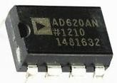
- Varol bridge: is a nerve the link between the cerebellum and the brain large and the left and right hemispheres of the brain small.
- Marrow Advances: Forming parts under the brain stem and
connects varol bridge with bone marrow behind.

Electrode
Electrode Based on their properties, electrodes can be divided into: into two types, namely active electrode and passive electrodes. Active electrodes are electrode that has a pre-amplifier in it. Passive electrode is an ordinary electrode without a preamplifier in it. In use, low impedance is required between electrode surface and skin. Therefore, need to be given special preparation on the surface contact between the skin and the electrodes, such as epidermal scraping and gel application (Robinsar Parlindungan, 2008).

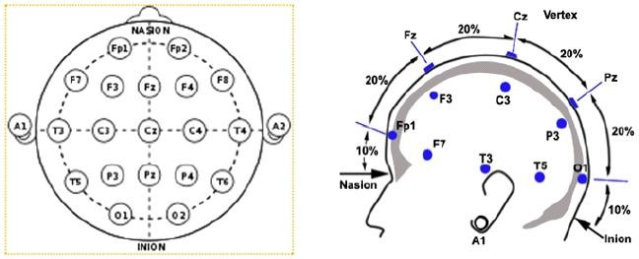
As for System international standard 10-20 electrode placement as in Figure 2.1.

Instrumentation Amplifier
Instrumentation amplifier is the first of the configuration of the EEG circuit [Andrew Paul Simms, 2014]. Because the high impedance output from the EEG source (scalp), for receiving signal, instrumentation amplifier implemented in front of the design that has a high input impedance of more than ten times the output impedance of the source (M. E. Chandrasiri, 2013).

Instrumentation amplifier used is the IC AD620. This IC is very suitable for medical instrumentation applications and uses low power consumption (1.5mW at 3V), which makes it good for portable design [M. Emin Sahin, 2016]. For more details, see in Figure 2.2.
Figure 2.2. IC AD620

The AD620 is an instrumentation amplifier with high accuracy low cost that only requires one external resistor to set gain 1 to 10000 with range supply 2.3V-18V. Therefore, making it suitable hardware for used in medical instrumentation (Bipra Chatterjee, 2017). The specifications of the AD620 as in Table 2.1.

Table 2.1. AD620 Specifications
Pin 1 | Gain Setting
Pin 2 | Negative Input
Pin 3 | Positive Input
Pin 4 | -Vs
Pin 5 | Ref
Pin 6 | Output
Pin 7 | +Vs
Pin 8 | Gain Setting

Filter
In general, the purpose of using filters is to improve the quality of a signal e.g., eliminate and reduce noise. Filters can also be used for get the information carried by the signal. Often the original signal has an amplitude that is smaller than noise. Getting lower the frequency of the signal the more difficult the signal detected. Therefore, in order to dampen the signal, the interference signal is used by the circuit filters (Herbert, 2011). Filters used in this study namely notch filter, high pass filter, and low pass filter. To make a filter circuit, it takes an operational amplifier (Op-Amp). Op-Amp which is used to make a filter circuit, namely type LM358 as in Figure 2.3.
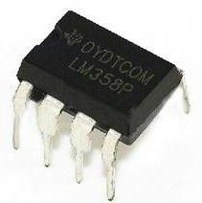

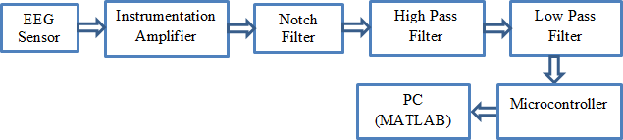
Figure 2.3. LM358

The specifications of the LM358 op-amp are as follows in Table 2.2.

Table 2.2. Specifications of LM358
Pin 1 | Output A
Pin 2 | Negative Input A
Pin 3 | Positive Input A
Pin 4 | GND
Pin 5 | Positive Input B
Pin 6 | Negative Input B
Pin 7 | Output B
Pin 8 | VCC

Arduino
Arduino microcontroller is an open-source physical computing platform that functions as a shaped electronic circuit boards. This microcontroller has input pins analog with the ADC (Analog to Digital Converter) feature and also has output pins voltage required to connect pre-designed EEG series. The Arduino Uno specifications are as follows:

Table 2.4. Arduino Uno Specifications
Microcontroller | ATmega328P
Operating Voltage | 5V
Digital I/O Pins | 14 (6 PWM output)
Analog Input Pins | 6
Flash Memory | 32 KB (ATmega328P)  where 0.5 KB is used for boot loader
SRAM | 2 KB
EEPROM | 1 KB

III. RESEARCH METHOD
Signal Conditioning
The EEG signal is very weak signal because it has a very low voltage level in the microvolt range (about 100μV) (M.E. Chandrasiri, 2013). The weak EEG is conditioned using an analog circuit, then the signal is given amplifier and in the filter. As for the system block diagram EEG as in Figure 3.1.

Figure 3.1. Block Diagram EEG

- Instrumentation Amplifier
Instrumentation amplifier is the first configuration of the EEG circuit (Andrew Paul Simms, 2014). Because the high impedance output from the EEG source (scalp), for receiving signal, instrumentation amplifier implemented in front of the design that has a high input impedance of more than
ten times the output impedance of the source (M. E. Chandrasiri, 2013). A High Common Mode Rejection Ratio (CMRR) from instrumentation amplifier supports for picks up two signals from the scalp and strengthening it separately with the same reinforcement and gives a differential signal as an output (M.E. Chandrasiri, 2013).
- Notch Filter
The main source of EEG interference is the system electric power (Amlan Jyoti, 2016). Even though use battery to power on circuit, the circuit will still have noise. Therefore, a notch filter is required. Notch filter which is a kind of bandstop filter reducing narrow frequency range designed for reduce noise caused by interference from the surrounding power lines (M. Emin Sahin, 2016).
- High Pass Filter
To remove the dc offset from the signal before amplification, high pass filter with low cutoff frequency is used (M. E. Chandrasiri, 2013) and sharpen the wave brain to make signals look clearer to outputs (Sasikumar Gurumurthy, 2013).
- Low Pass Filter
The low pass filter was designed right before digital to analog conversion as an antialiasing filter. The LPF cut-off frequency is set to 40 Hz which is sufficient for delta, theta, alpha and analysis beta band and can reduce interference power lines to some degree (M. E. Chandrasiri, 2013) and is used for clarify brain waves (Sasikumar Gurumurthy, 2013).

PHQ-9
The PHQ-9 is a depression scale with nine statements to assist in diagnosing depression as well as selecting and monitoring treatment. The PHQ score range is from 0 to 27, because each item is rated from 0 (never) up to 3 (almost every day). PHQ scores 5, 10, 15, and 20 represents mild, moderate, moderate depression severe and heavy. The interpretation of the total score on the PHQ9 as shown in Table 3.1.

Table 3.1. Interpretation of the total score of PHQ-9
Total Score | Level of Depression
1-4 | Minimal Depression
5-9 | Mild Depression
10-14 | Moderate Depression
15-19 | Moderately Severe Depression
20-27 | Severe Depression

IV. RESULTS AND DISCUSSION
EEG Recording
For cases of depression focused EEG recording on the alpha wave where analysis results EEG recording to be performed based on standard pattern of EEG signal (G.C. Sih, 2013) as in Figure 4.1.

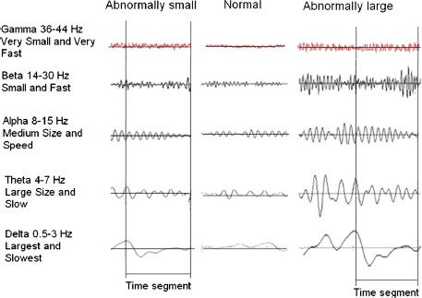
Figure 4.1. EEG Signal Standard Pattern

After knowing the results of the PHQ9 questionnaire, one of the participants who was categorized as depressed subjects were selected for recording EEG. EEG recording was carried out for more less than 3 minutes. As for the results obtained after recording as in Figure 4.2.
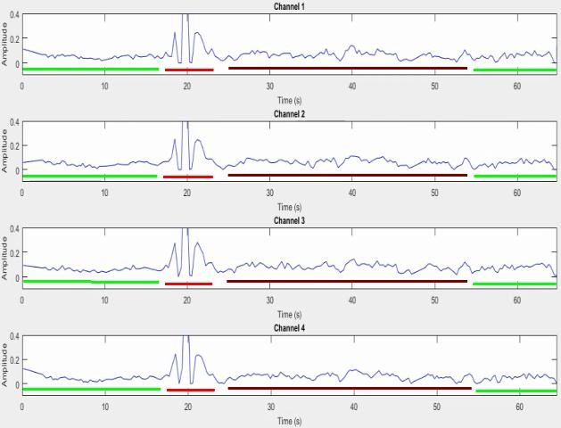
Figure 4.2. Result of Participants EEG Recording

In the picture above, the part marked green line when compared to the standard pattern EEG signal is a normal EEG signal. When abnormal EEG signal, it means it occurs imbalance in the brain and can be seen in waves marked with a red line. The wave is no longer in category of alpha waves instead of waves theta which is abnormally large. Then, for the wave with the brown line is shaped abnormal alpha waves abnormally large.

BIBLIOGRAPHY

Amlan Jyoti, Riku Chutia (2016), Design of Single Channel Portable EEG Signal Acquisition System for Brain Computer Interface Application. International Journal of Biomedical Engineering and Science (IJBES).
Andrew Paul Simms (2014), Reading and Wirelessly Sending EEG Signals Using Arduinos and XBee Radios to Control a Robot. Electrical Engineering University of Arkansas, Fayetteville.
Bipra Chatterjee, L. M. Saini, Tapan Kumar Ghandi (2017), Non-Invasive Wireless EEG Monitor. International Conference on Energy, Communication, Data Analytics and Soft Computing.
Esmeralda C. Djamal & Harijono A. Tjokronegoro (2005), Identifikasi dan Klasifikasi Sinyal EEG Terhadap Rangsangan Suara dengan Ekstraksi Wavelet dan Spektral Daya. Departemen Teknik Fisika ITB.
Hansu Cai, Jiashuo Han, Yunfei Chen, Xiaocong Sha (2018), A Pervasive Approach to EEG-Based Depression Detection.
Jian Shen, Shengjie Zhao, Yuan YaoYue Wang, Lei Feng (2017), A novel depression detection method based on pervasive EEG and EEG splitting criterion. IEEE International Conference on Bioinformatics and Biomedicine (BIBM).
Jian Shen, Xiaowei Zhang, Bin Hu, Gang Wang (2019), An Improved Empirical Mode Decomposition of Electroencephalogram Signals for Depression Detection.
M.E. Chandrasiri, R.M.T.M. Dhanapala, W.G.K.G. Kumari, R. Ranaweera (2013), PC Based Electroencephalogram System. IEEE 8th International Conference on Industrial and Information Systems.
M. Emin Sahin, Yunus Ucar, Feyzullah Temurtas (2016). An Implementation of Analog Portable EEG Signal Extraction System.
Mojtaba Hajian, Mohammad Hassan Moradi (2017), Quantification of depression disorder using EEG signal. 24th national and 2nd International Iranian Conference on Biomedical Engineering (ICBME), Amirkabir University of Technology, Tehran, Iran. U.
Naracoba Pada Stimulasi Akupuntur GI. Instrumentasi dan Kontrol Institut Teknologi Bandung.
Rajendra Acharya, Vidya K. Sudarshan, Hojjat Adeli (2015), A Novel Depression Diagnosis Index Using Nonlinear Features in EEG Signals. Department of Electronics and Computer Engineering Ngee Ann Polytechnic, 535 Clementi Road Singapore.
Robinsar Parlindungan (2008), Analisis Waktu-Frekuensi (TFA) Gelombang EEG.
Sasikumar Gurumurthy, Vudi Sai Mahit, Rittwika Ghosh (2013), Analysis and simulation of brain signal data by EEG signal processing technique using MATLAB. International Journal of Engineering and Technology (IJET).
Shamla Mantri, Dr. Pankaj Agrawal, Dr. Diptil Patil (2015), An Advanced Design for Depression Analysis through EEG Signal. International Journal of Scientific Engineering and Research (IJSER).
Yousef Mohammadi, Mojtaba Hajian, Mohammad Hassan Moradi (2019), Discrimination of Depression Levels Using Machine Learning Methods on EEG Signals. 27th Iranian Conference on Electrical Engineering (ICEE2019).

