KORESPONDENSI :
The partnerships and logistics leadership in the SMEs: The impact of digital supply chain implementation. Jurnal Uncertain Supply Chain Management (SCOPUS Q1)

Submited: Dilakukan melalui OJS

Your Paper -7684 - The impact of digital supply chain implementation
Inbox
Search for all messages with label Inbox
Remove label Inbox from this conversation
USCCM Editor |  | Mon, Oct 9, 2023, 8:19 AM
Dear Authors Thank you for your paper, We have received your submission paper.Title: The Digital supply chain: Its impact on the current and future structure of

noor wening |  | Mon, Oct 9, 2023, 9:30 AM
Dear Editor Team Thank you for the confirmation provided for our article entitled " The Digital Supply Chain: Its impact on the current and future structure of

USCM Editor |  | Wed, Oct 11, 2023, 3:29 PM
Dear Authors We have reached a decision regarding your submission Our decision is: Revisions Required ------------------------------------------------------ Rev

USCM Editor |  | Thu, Oct 12, 2023, 5:21 AM
Dear Authors, Please revise your manuscript according to the reviewers’ comments. Reviewer 1: 1. This paper has a potential to be accepted, but some important p

USCM Editor |  | Wed, Oct 18, 2023, 8:31 AM
Dear Authors Thank you for your revised paper According to our reviewers comments, your paper has been accepted ,The LoA will be sent after you sent to us the p

USCM Editor |  | Mon, Oct 23, 2023, 3:37 PM
Dear Authors Thank you for your revised paper According to our reviewers comments, your paper has been accepted ,The LoA will be sent after you sent to us the p

Evada Rustina |  | Mon, Oct 23, 2023, 9:31 PM
Thank you, for the revision. This is our last revised version. Here we attach our last article.

USCM Editor |  | Tue, Oct 24, 2023, 1:37 PM
Dear Rustina, We have received the revised manuscript, Your paper will be published within 60 working days. Thanks for submitting articles to us Thanks and Best

USCM Editor |  | Tue, Oct 24, 2023, 1:40 PM
Dear Rustina, Thank you very much, We have received your payment 1836 USD to our paypal account,

USCM Editor |  | Thu, Nov 9, 2023, 4:50 PM
Dear Evada Kindly, please visit our website at https://www.growingscience.com/uscm/online.html https://www.growingscience.com/uscm/online/uscm_2023_208.pdf down

Evada Rustina |  | Thu, Nov 9, 2023, 9:32 PM
Dear USCM Editor After we read carefully, then based on the final paper that we have sent, the name of the author Nur Cahyani, her affiliate: STIT Muhammadiyah

Evada Rustina |  |  | Thu, Nov 9, 2023, 9:40 PM
Dear USCM Editor, I have filled out and signed CONTRIBUTING AUTHOR COPYRIGHT RELEASE FORM. Here is attached the formular. Thanks in advance. Best regards

- USCM Editor <uscm.editorial@gmail.com> | Mon, Nov 13, 2023, 7:40 AM
to Evada, nurcahyani.kalil, me, masmintosragen, samuel_tarigan, yogimakbul, meii, hpratiwi, irmawati

Dear Author

please Check
https://www.growingscience.com/uscm/online/uscm_2023_208.pdf
ReplyReply allForward
Add reaction

REVISI Tanggal 11-10-2024 Revisi 3
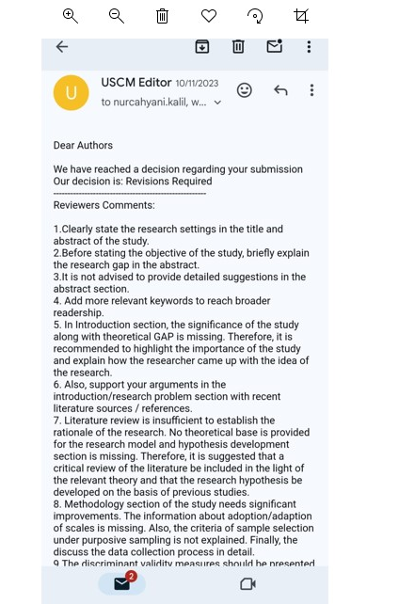
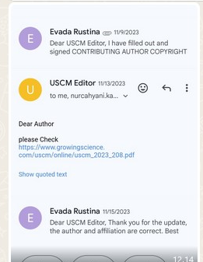

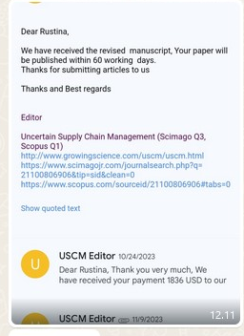

Tanggal 24-10-2024: pernyataan akan dipublikasi
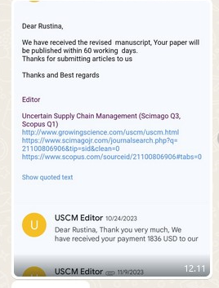
Terbit LOA
