KORESPONDENSI:

JUDUL : The Role Of Trust As A Mediator Between Extraversion And Knowledge Sharing of High School Employees.
NAMA JURNAL : International Journal of Economics, Business and Innovation Research (IJEBIR), Vol. 3 No. 01 (2024): January
INDEX JURNAL : EBSCO, BASE, PROQUEST, GOOGLE SHOLAR, CiteFactor, J-GATE INDEX, Copernicus International
STATUS : Penulis ke-2

Submit
November,18th, 2023
Dear editor

My name is Evada Rustina, I am planning to submit my manuscript to this journal. I hope that you will give me a favor of reviewing and publishing my manuscript for the latest edition entitled.
“ The role of trust as mediator between extroversion and knowledge sharing of high school employees”

Attached is my manuscript looking forward to hearing from you soon.

Best regards,

Rustina

Balasan Revisi:
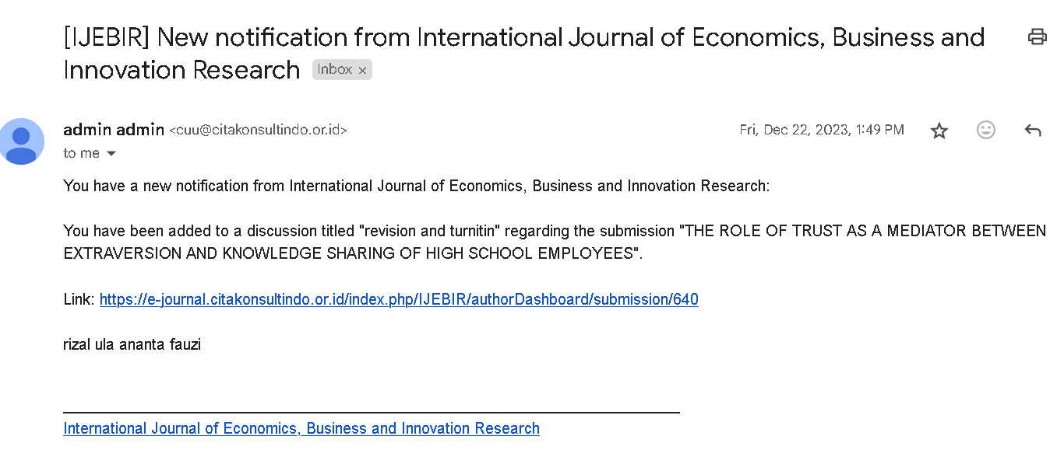

Dec,23th, 2023

Dear editor

Thank you very much for the opportunity to review and evaluate my article for publication in IJEBIR with the title “ The role of trust as mediator between extroversion and knowledge sharing of high school employees”

Attached is my manuscript revision looking forward to hearing from you soon.

Best regards,

Rustina

LOA
