KORESPONDENSI

JUDUL : Optımızatıon Of Employee Performance of Regıonal Technıcal Implementatıon Units to Expedıte Shıp Departure Actıvıtıes
NAMA JURNAL : Asian Journal of Management Entrepreneurship and Social Science (AJMESC), 29/10/2023
Ref : Ajmesc_October_2023_03453.
INDEX JURNAL : EBSCO, DOAJ, COPERNICUS International , CROSREff, Google Scholar, CiteFactor, ProQues, EuroPub, Semantic Scholar, PUBLONS, BASE, J-GATE
STATUS : Penulis ke-2

Submit
Augt,18th, 2023
Dear editor

My name is Evada Rustina, I am planning to submit my manuscript to this journal. I hope that you will give me a favor of reviewing and publishing my manuscript for the latest edition entitled.
“ Optımızatıon Of Employee Performance of Regıonal Technıcal Implementatıon Units to Expedıte Shıp Departure Actıvıtıes ”

Attached is my manuscript looking forward to hearing from you soon.

Best regards,

Rustina

Revisi 1,2 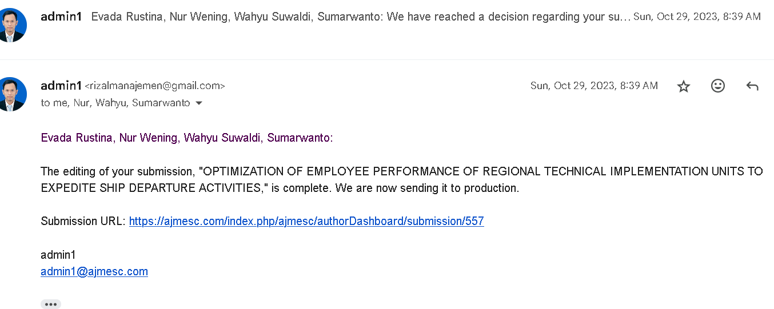

LOA, ACCEPTED
